UNIVERSAL FORWARDER

1. Objective
To install Splunk Universal Forwarder on a Windows 10 machine, configure it to collect Sysmon logs, and forward them securely to a Splunk Enterprise indexer running on Ubuntu Linux.

2. Prerequisites (VERY IMPORTANT – often missed)
Before starting, ensure:
- Splunk Enterprise is already installed and running on Ubuntu
  - Splunk Web accessible at:
  - http://<Ubuntu-IP>:8000
  - Receiving port 9997 is enabled on the indexer
- Windows and Ubuntu are on the same network (Host-only / NAT as per lab)
- Sysmon is already installed and generating logs on Windows
  - Event Viewer →
Applications and Services Logs → Microsoft → Windows → Sysmon → Operational

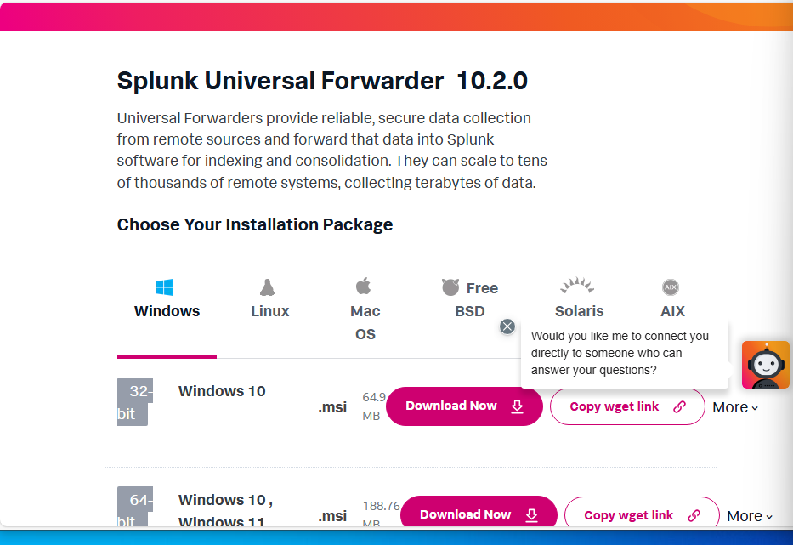
3. Download Splunk Universal Forwarder (Windows)
- Open browser on Windows machine
- Go to:
https://www.splunk.com/en_us/download/universal-forwarder.html
- Login with Splunk account
- Select:
  - Windows
  - 64-bit
- Download the MSI installer

4. Install Splunk Universal Forwarder (GUI Steps)
- Right-click the downloaded .msi file
- Click Run as administrator
- Click Next
- Accept the License Agreement
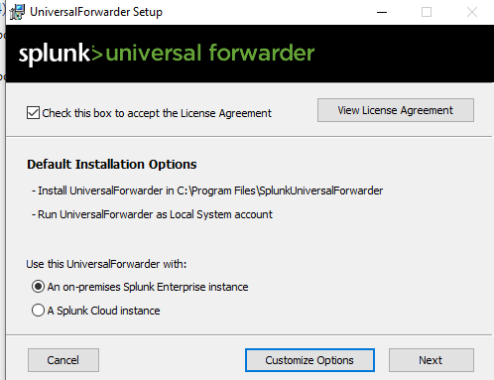
- Click Next

Important installer options (DO NOT SKIP)
- Username & Password
  - Create a Splunk admin username and password
  - (This is for the forwarder CLI)
- Deployment Server
  - Leave unchecked / blank (skip)
  - Click Next
- Receiving Indexer
  - Leave blank (we configure later)
  - Click Next
- Click Install
- Click Finish
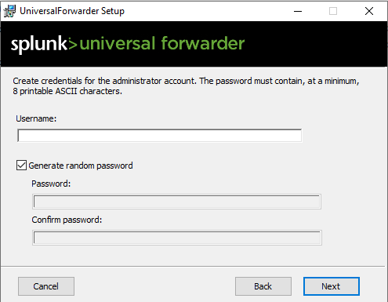
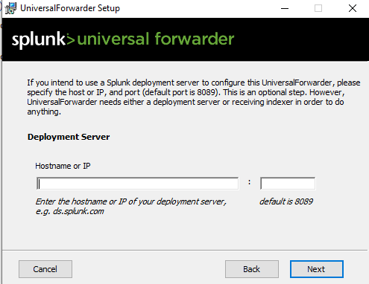

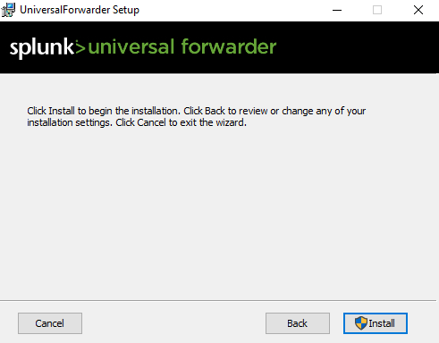
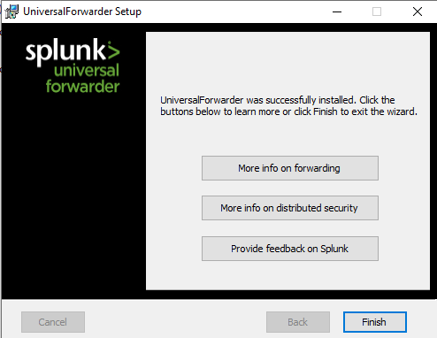

5. Verify Universal Forwarder Service (Missed by many)
- Press Win + R
- Type services.msc
- Check SplunkForwarder
  - Status should be Running
  - Startup type: Automatic

6. Configure outputs.conf
This tells the forwarder where to send logs.
Correct Indexer IP
- Ubuntu Splunk Indexer IP:
- 192.168.56.102

Steps
- Open Notepad as Administrator
- Go to:
- C:\Program Files\SplunkUniversalForwarder\etc\system\local\
- Create a new file named:
- outputs.conf

Paste EXACTLY this (no extra spaces):
[tcpout]
defaultGroup = indexer_group

[tcpout:indexer_group]
server = 192.168.56.102:9997
- Save the file

7. Configure inputs.conf (Sysmon Log Collection)
This tells the forwarder what logs to collect.

Steps
- Open Notepad as Administrator
- Go to: C:\Program Files\SplunkUniversalForwarder\etc\system\local\
- Create a file named:inputs.conf

Paste EXACTLY this:
[WinEventLog://Microsoft-Windows-Sysmon/Operational]
disabled = 0
index = main
sourcetype = WinEventLog:Microsoft-Windows-Sysmon/Operational
renderXml = true

8. Permission Fix
Splunk Forwarder must have permission to read Sysmon logs.

Steps
- Press Win + R
- Type:secpol.msc
- Go to:Local Policies → User Rights Assignment
- Open:Manage auditing and security log
- Click Add User or Group
- Click Object Types
- Select Groups only
- Type:
- Administrators
- Click Check Names
- Click OK → OK

9. Restart Splunk Universal Forwarder
Open PowerShell as Administrator and run:
net stop SplunkForwarder
net start SplunkForwarder
Verify:
Get-Service SplunkForwarder
Status must be:
Running

10. Verify Sysmon Logs on Windows (Local Check)
Run in PowerShell (Admin):
wevtutil qe Microsoft-Windows-Sysmon/Operational /c:5

11. Verify Forwarding (Log Level)
Get-Content "C:\Program Files\SplunkUniversalForwarder\var\log\splunk\splunkd.log" | Select-String 9997

12. Verify in Splunk Web (Final Confirmation)
- Open browser: http://192.168.56.102:8000
- Go to Search
- Set Time Range → All time
- Run: index=main
Then Sysmon-specific searches:
index=main EventCode=1
index=main EventCode=3
index=main EventCode=11
✔ Events visible = SUCCESS

